

**IST 737: VISUAL ANALYTICS DASHBOARDS**

A Visual Exploration of Natural Disasters, and Economic Impact in the USA (2000 - 2020)

**Team Members**

Bhanu Kirrann Garikipati

Indraneel Somayajula

Madhumitha Saravanan

Sindhuja Maheswaran

**CONTENTS:**

1. Data sources used

2. Project Overview

3. Dashboard 1: Disaster Analysis: Monthly & Yearly Analysis and Maximum Occurrences by County

4. Dashboard 2: Charting Disaster Dynamics: Mapping Frequency, Recovery

Time, and Regional Patterns:

5. Dashboard 3: Exposing Human Loss: Analyzing Natural Disaster Impact Across USA (2000- 2023)

6. Dashboard 4: Impact Unveiled: Economic Consequences of Natural Disaster in the USA (2013-2023)

**DATA SOURCES USED:**

1. Incident type dataset:

This data source comprises different natural disasters and its relevant data like declaration date , year , counties , state etc.

<https://www.fema.gov/data-visualization/disaster-declarations-states-and-counties>

2. Economic Damage from Natural Disasters Type:

This data source comprises different natural disasters and the economic damage implicated by these natural disasters.

<https://ourworldindata.org/grapher/economic-damage-from-natural-disasters>

3. Natural disasters Value Dataset:

This dataset comprises types of natural disasters and how it affects millions of people every year.

<https://ourworldindata.org/natural-disasters>

**PROJECT OVERVIEW:**

This project aims to conduct a comprehensive visual exploration of natural disasters and their economic and human impact in the United States from 2000 to 2020. The study will employ data-driven analyses and data visualization techniques to elucidate the frequency, severity, regional distribution, and economic consequences of various natural disasters during the specified timeframe.

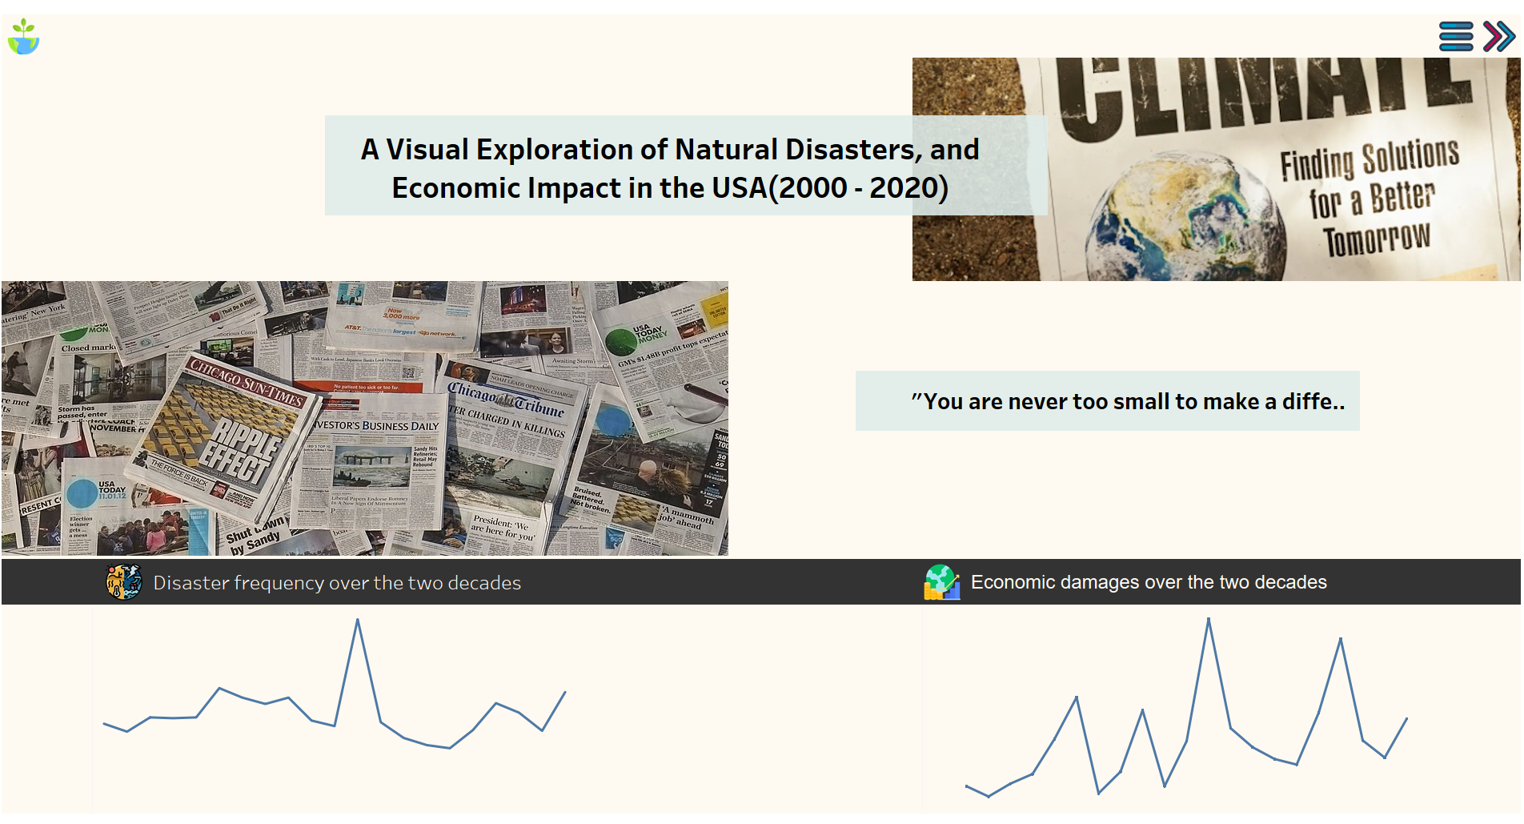

**1.Exploring USA's Natural Disasters: Monthly and Yearly Insights with County Mapping:**

This dashboard designed to provide detailed analyses of natural disasters at the county level, focusing on monthly and yearly trends and highlights the counties in the United States that have experienced the maximum number of disasters within a specified timeframe. It allows users to quickly identify hotspots of disaster activity and understand the challenges faced by these high-risk areas.

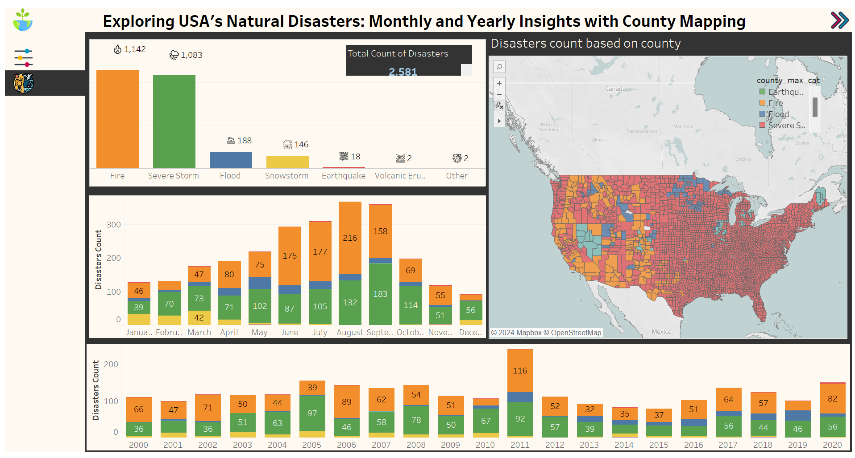

**2. Charting Disaster Dynamics: Mapping Frequency, Recovery Times, and Regional Patterns:**

The dashboard's purpose: to visually map disaster categories and subcategories across states in the USA, along with average recovery times for each disaster type. The interactive map visually represents the different disaster categories (e.g., hurricanes, wildfires, floods) and their occurrences in various states.

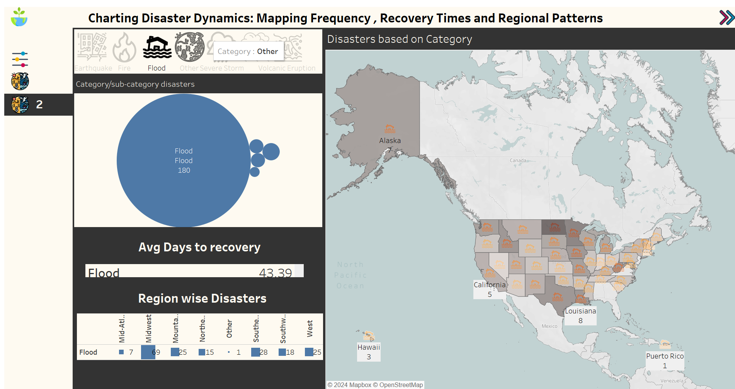

**3. Exposing Human Loss: Analyzing Natural Disaster Impact Across USA:**

Embark on a journey to understand the profound human impact of natural disasters in the USA from 2000 to 2023. Witness the evolution of mortality rates, injuries, homelessness, and the overall human toll through interactive bar plots and comprehensive line graphs. Each visualization unveils the specific disasters and their associated human consequences, offering a nuanced perspective on the enduring challenges faced by communities across decades.

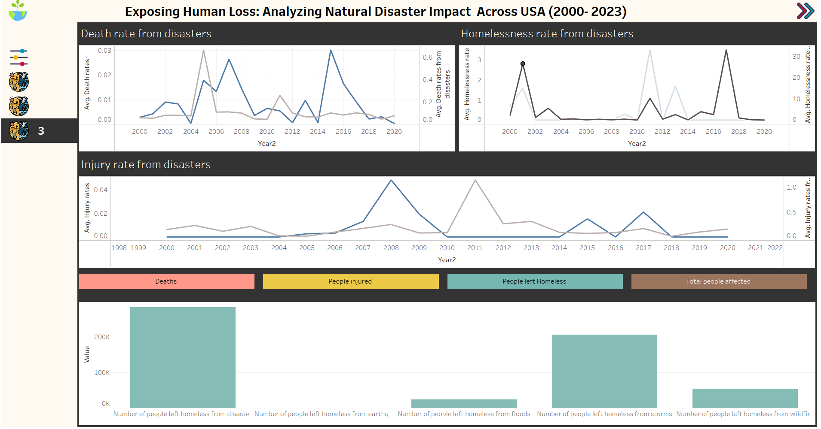

**4. Impact Unveiled: Economic Consequences of Natural Disasters in the**

**USA:**

Experience a comprehensive analysis of the economic ramifications of natural disasters across the United States from 2013 to 2023. Explore our detailed time series analysis, showcasing the financial impact over time alongside specific disaster events. Navigate through our interactive map to understand county-wise economic repercussions, and delve into the top 5 states and their most affected counties for deeper insights into the extent of damage.

